**Portumna Courthouse**

**Café**

**Expression of Interest**

**October 2024**

***Confidentiality Statement***

*All interested parties are requested to treat all information which may be gained in the course of this process in the utmost confidentiality, and not disclose any such information to any person or company not directly concerned with the response to this document. In addition, the Civic Theatre agrees to treat all information provided in relation to this document as strictly private and confidential, and to limit circulation of the information to only those directly involved in the evaluation of this tender.*

**Introduction**

Galway County Council invites expressions of interest from suitably qualified and experienced catering companies or individuals for the opportunity to operate the café within the newly refurbished setting of Portumna Courthouse. This document explains what the new courthouse will do and the objectives & requirements for the café and for making an expression of interest.

Respondents must reply to this Request for Expression of Interest before the deadline set out below

Galway County Council can facilitate site visits by request.

**Portumna**

Portumna is located in south-east County Galway, approximately 68 kilometres southeast of Galway City, 31 kilometres south of Ballinasloe and 24 kilometres west of Birr. The town straddles the county boundary with County Tipperary, and it is recognised as the principle urban setting in south-east County Galway serving an extensive rural hinterland on either side of the county divide.

Portumna possess an abundance of natural and built heritage assets. Beautiful landscapes and accessible water resources provide the backdrop for a multitude of outdoor recreation and leisure activities. The town is also steeped in a rich and storied history where visitors can immerse themselves in the breadth of stories depicting all facets of Irish life down through the ages. The town represents a key destination within Ireland’s Hidden Heartlands and will be central to the successful delivery of the Tourism Masterplan for the Shannon and the Lough Derg Visitor Experience Development Plan (VEDP).

**The Newly Refurbished Courthouse and Café**

Portumna courthouse is under the ownership of Galway County Council, being a detached four-bay, two-storey neo-Classical courthouse, dated 1847. It is a Protected Structure (Ref: 471) and had up until recently remained vacant for nearly 20 years.

Now the subject of a multimillion-euro project to bring it back to life, Portumna Courthouse is a national flagship regeneration project for Galway County Council who are using the project as an exemplar of the sustainable adaptive reuse of heritage buildings. Galway County Council will work with our partners to create a significant visitor attraction at the main building, offering visitors to participate in activities and events, visit the exhibitions, and enjoy the café space that will be at the heart of the newly created community.

**Figure 1 – Site Location Clonfert Avenue, Portumna**

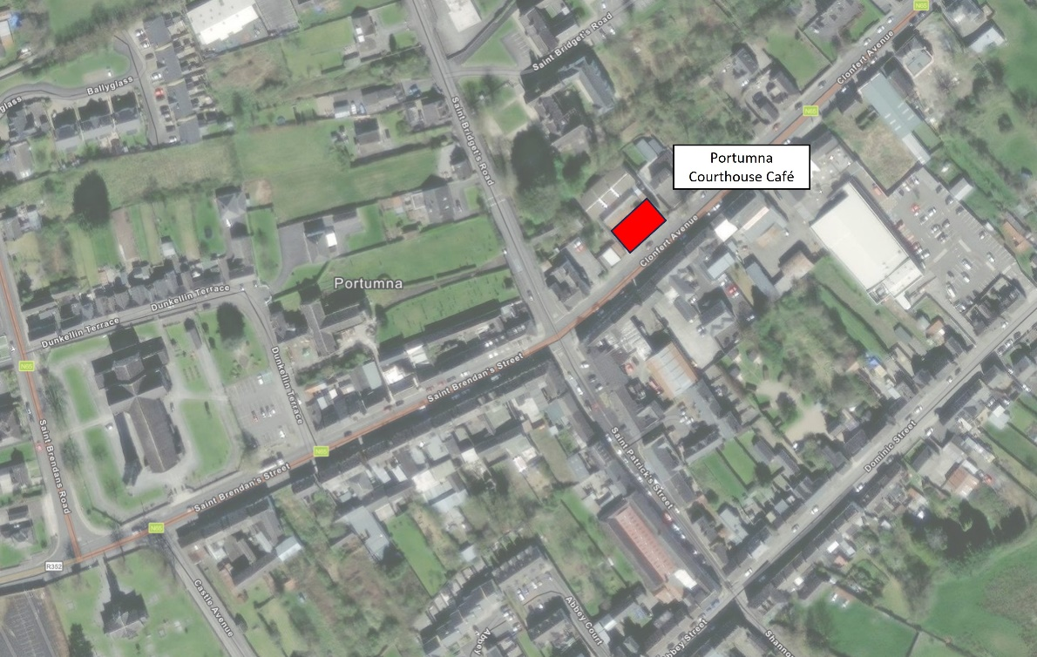

Scheduled to open in March 2025, we are looking for a partner organisation to the manage and operate the café. We want to create a vibrant and exciting space and are looking for an organisation that will bring passion to the project.

This is an exciting opportunity for the right partner. The main ground floor of the Courthouse is being refurbished to create a flexible event space. The upper floor will provide a meeting room and 4no. remote working spaces for businesses and / or individuals.

We have created a multi-functional, well-equipped kitchen with the capacity to store, prepare and cook for the café to support events, meeting and conferences. We are keen to work collaboratively with a partner whose brand adds value to the offer and can help shape the new Courthouse into a true destination in Portumna.

The café occupies part of the ground floor space at the heart of Portumna Courthouse. The space is of new build contemporary construction and design. It provides circa 50 seats through a combination of internal, courtyard and terrace seating options. The space is fully accessible with on-site toilets and located right in the heart of Portumna town centre.

The café will have the opportunity to provide hospitality and catering services to all users and visitors to the building. The use of the meeting and office spaces on the first floor will provide additional and reliable income stream for the café. The use of the venue for private hire events will be an essential part of day-to-day operations. The café operator will be well placed to support abroad set of events.

**The Business Opportunity - *What we can offer.***

* A unique setting and environment.
* Reliable income streams through regular visitors.
* The opportunity to support event catering.
* A modern, spacious, and well-designed commercial kitchen, counters and seating.
* The opportunity to build a destination café and showcase your brand in a high-profile local project.
* A five-year lease.
* A partnership approach with collaboration and support to ensure the café’s success.

**The Business Opportunity - *What we want from you.***

We are looking for a business motivated to deliver this exciting project. At this stage in the process, we are looking for expressions of interest from operators who feel they could work with us to deliver the high quality offer the Courthouse deserves. We will need you to:

* Offer visitors and users a changing range of good quality products including healthy, seasonal, and locally sourced food and drink to eat in or take away.
* Work with us to create a successful café that is in keeping with a sustainable and community ethos and supports both visitors to events, potential tenants and drop in café users.
* Jointly market the café and the Courthouse with us ad participate in promotional activity to drive footfall to the site.
* An entrepreneurial approach to developing menus, promotions and opportunities that align with the wider site and its changing programme of activity.
* Tell us you are interested by completing the form below!

**Terms and Conditions**

The successful candidate will:

* operate the cafe in a professional and flexible manner that will closely reflect and complement the Courthouses work and ethos;
* run the café as an integral part of the overall Courthouse offering;
* bring an imaginative new feel to the café, with a fresh and innovative approach to this key facility in the theatre;
* offer value for money and a quality product;
* offer a reliable, family/arts friendly service, ensuring all visitors to the Courthouse whether visiting artists, café customers, ticket purchasers or contractors are made to feel welcome;
* provide catering as agreed, for example for theatre dinner events, sponsor evenings and special theatre occasions;
* demonstrate support of the activities of the Courthouse and a clear commitment to its artistic programme and its public;
* work collaboratively with the management and staff of Galway County Council in the best interests of the facility;
* ensure that Health & Safety and Child Protection policies and procedures are respected at all times, in the interests of café staff and customers, as well as staff and public.

**Submissions should include brief details of:**

* The expression of interest should give information on the type of café offering proposed to include food/beverages/eat-in/take-out options.
* Proposed opening hours;
* Proposed pricing structure (food, soft drinks, tea & coffee, etc.);
* Proposed staffing and management structure;
* Vision for engaging with Galway County Council;
* Proposed marketing and publicity strategy;
* Knowledge of, and commitment to compliance with the accepted legal standards and operational procedures of catering;
* Proposal for dealing with waste disposal and cleaning requirements;
* Names and contact details for two references;

The successful applicant will be obliged to provide the following prior to commencement:

• an up-to-date Tax Clearance Cert (with new certs provided annually to the management of the theatre);

• proof of Public Liability Insurance and Employer Liability Insurance. The successful applicant will be required to indemnify Galway County Council against all claims arising from injury caused to members of the public, members of the café staff in the performance of the catering operations or the use of any catering materials or equipment, including food poisoning. The successful applicant will be required, prior to commencing operations, to submit to Galway County Council their Employers Liability Insurance Policy, duly extended to indemnify Galway County Council as principals and a policy of insurance to cover Public Liability Insurance. Policies to cover cash held on premises and cash-in-transit and motor insurance will also have to be submitted by the successful applicant;

• a copy of Food Hygiene Certificate;

• a Health & Safety Policy in relation to their staff, their areas of operation in the building, and the specific nature of their business;

• adherence to licence requirements/IMRO payments should background music be played in the café area;

• proof of all necessary licences;

• a full list of café staff, ensuring all members of the café team are introduced to Galway County Council (continually implemented as staff change);

**How to Apply**

Expressions of Interest will be assessed in reference to the guidelines and the listed objectives & requirements included in this document. A pre-tender site inspection can be arranged at an agreed time. **The deadline for applications is 5pm 15th November 2024**. Shortlisting may apply. Please submit your application to [regeneration@galwaycoco.ie](mailto:regeneration@galwaycoco.ie) with ‘Expression of Interest Portumna Courthouse Café’ in the subject line. If you have any questions, please do not hesitate to call Ronan Conway at 091 509638.

**Appendices:**

* Building Floor Plans and Elevations including extent of Floor Area, Eternal Spaces forming part of the lease.
* Walk Through Video of overall project.
* 3D Visuals of Café space.